This series of exercises will build on one another in order to demonstrate how to create custom components using a standard architecture in MPages development utilizing work done in previous training exercises.
Exercise List:
- Create Custom Driver Program
- Component Without AJAX
- Component With AJAX
- Utilizing Component Options
- Adding Tooltips using JQuery
- Utilizing Components into a Standard V6 MPage
- Utilizing Components into a Standard V5 MPage
- Utilizing Components into a Standard V4 MPage

Exercise #1: Create Custom Driver Program
Objective: Create the base architecture in which to utilize custom components. NOTE ➔ You can skip steps 3 through 7 if you have created the driver program already (HTML and JS exercises).

In this exercise, a custom driver program will be created that can be used to create stand-alone custom MPages.

- In Discern Visual Developer, open a new blank file. Save the file to the backend server (i.e. ccluserdir) as zzz_mpage.html where “zzz” will be your special mnemonic for the rest of this document. For example, Save As cjg_mpage.html.
- Copy the code between the dashed lines below and paste into zzz_mpage.html (where zzz is your special mnemonic). Save the file. The instructor will later provide everyone with a “starter” for the static content. Note that the javascript is at the end of the file so that the page loads the body before any javascript is loaded.
-----------------------------------------------------------------------------------------------------------

<!DOCTYPE html PUBLIC "-//W3C//DTD XHTML 1.0 Strict//EN" "http://www.w3.org/TR/xhtml1/DTD/xhtml1-strict.dtd">
<?xml version="1.0" encoding="UTF-8" ?>
<html xmlns="http://www.w3.org/1999/xhtml" lang="en" xml:lang="en">
<head>
<meta http-equiv="Content-Type" content="APPLINK,CCLLINK,MPAGES_EVENT,XMLCCLREQUEST,CCLLINKPOPUP,CCLNEWSESSIONWINDOW" name="discern"/>
<link type="text/css" rel="stylesheet" href="$SOURCE_DIR$\css\mp_common.css"></link>
<link type="text/css" rel="stylesheet" href="$SOURCE_DIR$\custom-components\css\custom-components.css"></link>
</head>
<body>
<div class="section org-no-header">
<div class="pg-hd">
<h1><span class="pg-title">Sample MPage</span></h1>
<span class="page-ctrl">
<a class="expAll" href="javascript:MP_COMMON.expandAll();">Expand All</a>/<a class="expAll" href="javascript:MP_COMMON.collapseAll();">Collapse All</a>
</span>
</div>
</div>
</body>
<script type="text/javascript" src="$SOURCE_DIR$\js\jquery-1.9.1.min.js"></script>
<script type="text/javascript" src="$SOURCE_DIR$\js\mp_custom_component_core.js"></script>
<script type="text/javascript" src="$SOURCE_DIR$\js\mp_common.js"></script>
<script type="text/javascript" src="$SOURCE_DIR$\custom-components\js\custom-components.js"></script>
<script type="text/javascript">
var MPAGE_REC = $MPAGE_REC$.MPAGE_REC;
MP_COMMON.InitializeMPage();
</script>
</html>
-----------------------------------------------------------------------------------------------------------

- Create a new ccl program. This program will execute the HTML file.
- In Discern Visual Developer, open a new blank file. Save the file to the backend server (i.e. ccluserdir) as zzz_mpage_driver.prg where zzz is your special mnemonic.
- Copy the code between the dashed lines below and paste into your zzz_mpage_driver.prg. Replace the zzz in the ‘drop’ and ‘create’ commands with your special mnemonic.
- Be sure to change the name of the html file in the default prompt to match your own by replacing the zzz with your special mnemonic.
- Save and include your zzz_mpage_driver.prg.
-----------------------------------------------------------------------------------------------------------
drop program zzz_mpage_driver:dba go
create program zzz_mpage_driver:dba

prompt
"Output to File/Printer/MINE" = "MINE"
,"Patient Id:" = 0.0
,"Encounter Id:" = 0.0
,"User Id:" = 0.0
,"Static Content Directory:" = ""
,"HTML File:" = "ccluserdir:zzz_mpage.html"
with outdev, person_id, encntr_id, user_id, sourcedir, html_file

/***************************************************************************
* Declare Records *
***************************************************************************/
free record mpage_rec
record mpage_rec (
1 person_id = f8
1 encntr_id = f8
1 user_id = f8
1 source_dir = vc
1 html_file = vc
)

/***************************************************************************
* Assign prompts to record structure *
***************************************************************************/
set mpage_rec->person_id = $person_id
set mpage_rec->encntr_id = $encntr_id
set mpage_rec->user_id = $user_id
set mpage_rec->source_dir = $sourcedir
set mpage_rec->html_file = $html_file

/***************************************************************************
* Read in HTML and display error HTML if incorrect *
***************************************************************************/
record getREQUEST (
1 Module_Dir = vc
1 Module_Name = vc
1 bAsBlob = i2
)

record getREPLY (
1 INFO_LINE[*]
2 new_line = vc
1 data_blob = gvc
1 data_blob_size = i4
%i cclsource:status_block.inc
)

; Read in the html file
set getrequest->module_dir= trim(mpage_rec->html_file, 3)
set getrequest->Module_name = ""
set getrequest->bAsBlob = 1
execute eks_get_source with replace (REQUEST,getREQUEST),replace(REPLY,getREPLY)
if(getREPLY->status_data.status = "F")
; Output No HTML File Found!
set getReply->data_blob = BUILD2(
^<html><head><title>MPage Error</title></head>^,
^<body><div>HTML file "^,mpage_rec->html_file,^" could not be found!</div>^,
CHAR(10),CHAR(13),
^</body></html>^
)
endif

/***************************************************************************
* Replace special strings in HTML File *
***************************************************************************/
; Replace $SOURCE_DIR$ in the HTML file with the actual location of the static_content files
set getReply->data_blob = replace(getReply->data_blob,"$SOURCE_DIR$", mpage_rec->source_dir,0)

; Replace $MPAGE_REC$ in the HTML file with the JSON for the record
set getReply->data_blob = replace(getReply->data_blob,"$MPAGE_REC$", CNVTRECTOJSON(mpage_rec),0)

/***************************************************************************
* Outputs HTML to the display *
***************************************************************************/
call echorecord(mpage_rec)
set _MEMORY_REPLY_STRING = getReply->data_blob

#exit_script
free record mpage_rec

end
go

-----------------------------------------------------------------------------------------------------------
- The instructor should provide everyone with a “starter” for the static content. Please rename the “zzz” on the main folder to your special mnemonic, and place in the static_content folder (ie. I:\winintel\static_content).
- A tab for each student will have to created using PrefMaint. The instructor will do this since multiple people cannot be in PrefMaint at the same time.
- Completely close Powerchart for the changes in PrefMaint to take effect
- Reopen PowerChart and open to your MPage.
- If correct the MPage should display an MPage header with the words “Sample MPage” and some buttons to collapse all/expand all (components). These buttons will be used at a later time.

Exercise #2: Component Without AJAX
Objective: Create a custom component that will not need to call a CCL object to obtain data.
In this exercise, a custom component will be created that will demonstrate how to create a component that does not need CCL.

- Open the custom-components.js and custom-components.css files in your static_content folder created in the previous exercise. This javascript file will perform much of the processing for the MPage Components.
- In Notepad++:
- Use File->Open or Ctrl+O to navigate to your respective folder in the STATIC_CONTENT folder in the code warehouse.
- Once in your folder, find the custom-components.js file located at yourFolder\custom-components\js\custom-components.js.
- While here, go ahead and open the custom-components.css file, which will be used later, located at yourFolder\custom-components\css\custom-components.css
- Copy the template code between the dashed lines below and paste into custom-components.js . Do a replace all on “zzz” with your special mnemonic, and do a replace all on “comp_name” with the name of “hyperlinks”. Save the file. The layout and function of each individual piece will be discussed by the instructor. Note that this code will be your template for future components which do not utilize AJAX.
-----------------------------------------------------------------------------------------------------------
/* Put name of component here */
MPage.namespace("zzz.comp_name");

zzz.comp_name = function(){};
zzz.comp_name.prototype = new MPage.Component();
zzz.comp_name.prototype.constructor = MPage.Component;
zzz.comp_name.prototype.base = MPage.Component.prototype;
zzz.comp_name.prototype.name = "zzz.comp_name";

zzz.comp_name.prototype.init = function(options) {
//code to perform before immediately rendering (usually nothing needed)
};

zzz.comp_name.prototype.addEventHandlers = function() {
var component = this;
var compId = component.getComponentUid();
var target = component.getTarget();

$("#"+compId+" .classOfElementWithinComponent").click(function(){
//some stuff to do when clicked
});
};

zzz.comp_name.prototype.getSubHeader = function( str ) {
//note that inline styles could be put in their own class and put as a second class for the div
return ["<div class='sub-title-disp' style='margin:-6px -6px 6px -6px;border-left:none;border-right:none;'>",str,"</div>"].join("");
};

zzz.comp_name.prototype.render = function() {
var component = this;
var compId = component.getComponentUid();
var target = component.getTarget();
var targetHTML = [];
//set and create subheader (uncomment and update if needed)
//targetHTML.push(component.getSubHeader("Selected Visit"));

//set the title text if needed (uncomment and update if needed)
//component.setProperty("headerTitle", "New Title");

//set the subtitle text next to header if needed (uncomment and update if needed)
//component.setProperty("headerSubTitle","(10)");

//set the component to collapsed (false)/expanded (true) if needed (uncomment and update if needed)
//component.setProperty("headerShowHideState",true);

//do something here with the targetHTML (component.data has NOTHING on it)

target.innerHTML = targetHTML.join("");

//this may or may not be needed.
//component.addEventHandlers();
}

-----------------------------------------------------------------------------------------------------------
- We now must update the render function to output html to the component. Copy and paste the code below into the render function replacing the code that currently exists.
-----------------------------------------------------------------------------------------------------------

var component = this;
var compId = component.getComponentUid();
var target = component.getTarget();
var targetHTML = [];
//set and create subheader (uncomment and update if needed)
//targetHTML.push(component.getSubHeader("Selected Visit"));

//set the title text if needed (uncomment and update if needed)
//component.setProperty("headerTitle", "New Title");

//set the subtitle text next to header if needed (uncomment and update if needed)
//component.setProperty("headerSubTitle","(10)");

//set the component to collapsed (false)/expanded (true) if needed (uncomment and update if needed)
//component.setProperty("headerShowHideState",true);
//do something here with the targetHTML (component.data has NOTHING on it)
targetHTML.push("<a href='http://www.w3schools.com'>W3Schools</a><br/>",
"<a href='http://www.jsonlint.com'>JSON Lint</a>");

target.innerHTML = targetHTML.join("");

//this may or may not be needed.
//component.addEventHandlers();

-----------------------------------------------------------------------------------------------------------

- Finally, we must set-up the component “skeleton” so that the component is loaded when executed. Update the zzz_mpage.html file body tag as shown below in yellow making sure that the namespace attribute is updated from “zzz” to your mnemonic created in step 3. This attribute will be used by the custom component architecture to know where to load the data to when the MP_COMMON.InitializeMPage function kicks off:
-----------------------------------------------------------------------------------------------------------

<!DOCTYPE html PUBLIC "-//W3C//DTD XHTML 1.0 Strict//EN" "http://www.w3.org/TR/xhtml1/DTD/xhtml1-strict.dtd">
<?xml version="1.0" encoding="UTF-8" ?>
<html xmlns="http://www.w3.org/1999/xhtml" lang="en" xml:lang="en">
<head>
<meta http-equiv="Content-Type" content="APPLINK,CCLLINK,MPAGES_EVENT,XMLCCLREQUEST,CCLLINKPOPUP,CCLNEWSESSIONWINDOW" name="discern"/>
<link type="text/css" rel="stylesheet" href="$SOURCE_DIR$\css\mp_common.css"></link>
<link type="text/css" rel="stylesheet" href="$SOURCE_DIR$\custom-components\css\custom-components.css"></link>
</head>
<body>
<div class="section org-no-header">
<div class="pg-hd">
<h1><span class="pg-title">Sample MPage</span></h1>
<span class="page-ctrl">
<a class="expAll" href="javascript:MP_COMMON.expandAll();">Expand All</a>/<a class="expAll" href="javascript:MP_COMMON.collapseAll();">Collapse All</a>
</span>
</div>
</div>
<!-- COLUMN SECTIONS -->
<div class="one-col">
<!-- COLUMN 1 -->
<div class="col1">
<!-- HYPERLINK COMPONENT -->
<div class="section with-header" namespace="zzz.hyperlinks">
<h2 class="sec-hd">
<span class="sec-hd-tgl"></span>
<span class="sec-title">
<span class="comp-header-name">Hyperlinks</span>
<span class="sec-total">Loading...</span>
</span>
</h2>
<div class="sec-content"></div>
</div>
<!-- END HYPERLINK COMPONENT -->
</div>
<!-- END COLUMN 1 -->
</div>
</body>
<script type="text/javascript" src="$SOURCE_DIR$\js\jquery-1.9.1.min.js"></script>
<script type="text/javascript" src="$SOURCE_DIR$\js\mp_custom_component_core.js"></script>
<script type="text/javascript" src="$SOURCE_DIR$\js\mp_common.js"></script>
<script type="text/javascript" src="$SOURCE_DIR$\custom-components\js\custom-components.js"></script>
<script type="text/javascript">
var MPAGE_REC = $MPAGE_REC$.MPAGE_REC;
MP_COMMON.InitializeMPage();
</script>
</html>

-----------------------------------------------------------------------------------------------------------

- Save your zzz_mpage.html
- Refresh your MPage in Powerchart to see this newly created component.

Bonus Exercises
- Make the component collapsed by default using the component property of “headerShowHideState” to false.
- Change the header to “<your first name> Hyperlinks” by updating the component property of “headerTitle.”

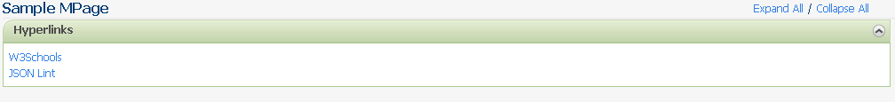
Exercise #3: Component With AJAX
Objective: Create a custom component that utilizes a CCL script to show data on a custom component.

In this exercise, a custom component will be created that will pull data from the CCL and then displayed using javascript.

- First, we need to create a CCL script that will pull in data which in this case is documents data. We are going to use the CCL script used in the MPages training which returns JSON. Copy/paste and then build/include the script below. Make sure to update all cases of “zzz” with your special mnemonic:
-----------------------------------------------------------------------------------------------------------

drop program zzz_mpage_documents_json:dba go
create program zzz_mpage_documents_json:dba

prompt
"Output to File/Printer/MINE" = "MINE"
, "Person Id:" = 0.0
, "Encounter Id:" = 0.0
, "Lookback Range:" = "6 M"

with outdev, personid, encntrid, lkbRange

free record documents
record documents (
1 document[*]
2 event_id = f8
2 title = vc
2 date = vc
)

declare inErrorCd = f8 with public, noconstant(uar_get_code_by("MEANING",8,"INERROR"))
declare DOCCd = f8 with public,constant(uar_get_code_by("MEANING", 53, "DOC"))
declare MDOCCd = f8 with public,constant(uar_get_code_by("MEANING", 53, "MDOC"))

/******************************************************
* Get the Document Title, Date and Event_Id *
******************************************************/
select into "nl:"
evtDate = format(ce.event_end_dt_tm,"mm/dd/yyyy hh:mm;;dq"),
evtTitle = ce.event_tag,
evtId = cnvtstring(ceb.event_id)
from
clinical_event ce,
ce_blob ceb

plan ce
where ce.person_id = $PersonId
and ce.event_end_dt_tm >= cnvtlookbehind($lkbRange,cnvtdatetime(curdate,curtime3))
and ce.valid_until_dt_tm > cnvtdatetime(curdate,curtime3)
and ce.encntr_id = $encntrid
and ce.result_status_cd != inErrorCd
and ce.event_class_cd in (DOCCd,MDOCCd)
join ceb
where ceb.event_id = ce.event_id
and ceb.valid_until_dt_tm > cnvtdatetime(curdate,curtime3)

order by ce.event_end_dt_tm desc

head report
cnt = 0
head ceb.event_id
cnt = cnt + 1
if (size(documents->document,5)<cnt)
stat = alterlist(documents->document, cnt+10)
endif
documents->document[cnt].event_id = ceb.event_id
documents->document[cnt].title = ce.event_tag
documents->document[cnt].date = format(ce.event_end_dt_tm,"mm/dd/yyyy hh:mm;;dq")
foot report
stat = alterlist(documents->document,cnt)
with nocounter

call echorecord(documents)

;Set public memory variable equal to our XML string
set _Memory_Reply_String = CNVTRECTOJSON(documents)

#exit_script
free record documents

end
go

-----------------------------------------------------------------------------------------------------------

- Look at the custom-components.js file that should already be open. Copy the lines below, and place below the code for the hyperlinks component. Make sure to replace the words “zzz” with your special mnemonic, and “comp_name” with the words “documents”. Note that this will be your template for creating custom components that utilize AJAX:
-----------------------------------------------------------------------------------------------------------
/* Put name of component here */
MPage.namespace("zzz.comp_name");
zzz.comp_name = function(){};

zzz.comp_name.prototype = new MPage.Component();
zzz.comp_name.prototype.constructor = MPage.Component;
zzz.comp_name.prototype.base = MPage.Component.prototype;
zzz.comp_name.prototype.name = "zzz.comp_name";
zzz.comp_name.prototype.cclProgram = "zzz_comp_name";
zzz.comp_name.prototype.cclParams = [];
zzz.comp_name.prototype.cclDataType = "JSON"; //possible values=> JSON, TEXT, XML

zzz.comp_name.prototype.init = function(options) {
//code to perform before immediately rendering (usually updating params is needed)
var component = this;
//clear cclParams in case of refresh
component.cclParams = [];
component.cclParams.push("MINE");
//CAN USE ANY OR ALL OF THE FOLLOWING IN ORDER AS NEEDED:
//component.cclParams.push(component.getProperty("personId"));
//component.cclParams.push(component.getProperty("encounterId"));
//component.cclParams.push(component.getProperty("userId"));
//component.cclParams.push(component.getProperty("PPRCode"));
//component.cclParams.push(component.getProperty("positionCd"));
};

zzz.comp_name.prototype.addEventHandlers = function() {
var component = this;
var compId = component.getComponentUid();
var target = component.getTarget();

$("#"+compId+" .classOfElementWithinComponent").click(function(){
//some stuff to do when clicked
});
};

zzz.comp_name.prototype.getSubHeader = function( str ) {
//note that inline styles could be put in their own class and put as a second class for the div
return ["<div class='sub-title-disp' style='margin:-6px -6px 6px -6px;border-left:none;border-right:none;'>",str,"</div>"].join("");
};

zzz.comp_name.prototype.render = function() {
var component = this;
var compId = component.getComponentUid();
var target = component.getTarget();
var targetHTML = [];
//set and create subheader (uncomment and update if needed)
//targetHTML.push(component.getSubHeader("Selected Visit"));

//set the title text if needed (uncomment and update if needed)
//component.setProperty("headerTitle", "New Title");

//set the subtitle text next to header if needed (uncomment and update if needed)
//component.setProperty("headerSubTitle","(10)");

//set the component to collapsed (false)/expanded (true) if needed (uncomment and update if needed)
//component.setProperty("headerShowHideState",true);

//do something here with the targetHTML (component.data will have data type defined by this.cclDataType)

target.innerHTML = targetHTML.join("");

//this may or may not be needed
//component.addEventHandlers();
};
-----------------------------------------------------------------------------------------------------------
- Update the line with “cclProgram” with the name of the object created in step 1 (remember to replace “zzz”:
-----------------------------------------------------------------------------------------------------------
zzz.documents.prototype.cclProgram = "zzz_mpage_documents_json";

-----------------------------------------------------------------------------------------------------------
- Uncomment the rows in the “init” function where the person id and encounter id are set as the parameters creating an “init” function similar to below. Also add a param for the lookback range prompt when this javascript code calls the CCL object (shown in yellow):
-----------------------------------------------------------------------------------------------------------
zzz.documents.prototype.init = function(options) {
//code to perform before immediately rendering (usually updating params is needed)
var component = this;
//clear cclParams in case of refresh
component.cclParams = [];
component.cclParams.push("MINE");
//CAN USE ANY OR ALL OF THE FOLLOWING IN ORDER AS NEEDED:
component.cclParams.push(component.getProperty("personId"));
component.cclParams.push(component.getProperty("encounterId"));
component.cclParams.push("6 M");
//this.cclParams.push(component.getProperty("userId"));
//this.cclParams.push(component.getProperty("PPRCode"));
//this.cclParams.push(component.getProperty("positionCd"));
};

-----------------------------------------------------------------------------------------------------------
- The last update for the javascript requires updating the “render” function. This function processes the data AFTER the CCL script returns data. Replace your whole “render” function with code between the dashed lines below. Make sure to save the file after updating remembering that all cases of “zzz” should be replaced with your special mnemonic:
-----------------------------------------------------------------------------------------------------------
zzz.documents.prototype.render = function() {
var component = this;
var compId = component.getComponentUid();
var target = component.getTarget();
var record = component.data.DOCUMENTS;
var doc_length = record.DOCUMENT.length;
var targetHTML = [];

//set and create subheader (uncomment and update if needed)
targetHTML.push(component.getSubHeader("Selected Visit last 6 months"));

//set the title text if needed (uncomment and update if needed)
//component.setProperty("headerTitle", "New Title");

//set the subtitle text next to header if needed (uncomment and update if needed)
component.setProperty("headerSubTitle","("+doc_length+")");

//set the component to collapsed (false)/expanded (true) if needed (uncomment and update if needed)
//component.setProperty("headerShowHideState",true);

//do something here with the targetHTML (component.data will have data type defined by this.cclDataType)
targetHTML.push("<div class='zzz-documents'><table>");
for (var i=0;i<doc_length;i++) {
var docObj = record.DOCUMENT[i];
var paramStr = component.getProperty("personId")+"|"+component.getProperty("encntrId")+"|" + docObj.EVENT_ID + "|Documents|31|CLINNOTES|341|CLINNOTES|1";

targetHTML.push(
"<tr>",
"<td title='Event Id: ", docObj.EVENT_ID,"'>", docObj.TITLE,"</td>",
"<td class='doc-detail'><a href=\"javascript:MPAGES_EVENT('CLINICALNOTE', '",paramStr,"')\">", docObj.DATE,"</a></td>",
"</tr>"
);
} // end for

// Close the table
targetHTML.push("</table></div>");

target.innerHTML = targetHTML.join("");

//this may or may not be needed
//component.addEventHandlers();
};

-----------------------------------------------------------------------------------------------------------
- Copy the code between the dashed lines below and paste into your custom-components.css. Make sure to update “zzz” with your special mnemonic and then save the file.
-----------------------------------------------------------------------------------------------------------
/* zzz.documents */
.zzz-documents table {table-layout:fixed;border-collapse:collapse;}
.zzz-documents td{color:#505050; border-bottom:1px solid #F4F4F4;}
.zzz-documents td.doc-detail{border-bottom:1px solid #F4F4F4;}

-----------------------------------------------------------------------------------------------------------
- The last step is to update the html to load this component. Add the below in yellow making sure to update “zzz” for the namespace attribute of the section div to your special mnemonic. Note that we put this component in the second column:
-----------------------------------------------------------------------------------------------------------
<!DOCTYPE html PUBLIC "-//W3C//DTD XHTML 1.0 Strict//EN" "http://www.w3.org/TR/xhtml1/DTD/xhtml1-strict.dtd">
<?xml version="1.0" encoding="UTF-8" ?>
<html xmlns="http://www.w3.org/1999/xhtml" lang="en" xml:lang="en">
<head>
<meta http-equiv="Content-Type" content="APPLINK,CCLLINK,MPAGES_EVENT,XMLCCLREQUEST,CCLLINKPOPUP,CCLNEWSESSIONWINDOW" name="discern"/>
<link type="text/css" rel="stylesheet" href="$SOURCE_DIR$\css\mp_common.css"></link>
<link type="text/css" rel="stylesheet" href="$SOURCE_DIR$\custom-components\css\custom-components.css"></link>
</head>
<body>
<div class="section org-no-header">
<div class="pg-hd">
<h1><span class="pg-title">Sample MPage</span></h1>
<span class="page-ctrl">
<a class="expAll" href="javascript:MP_COMMON.expandAll();">Expand All</a>/<a class="expAll" href="javascript:MP_COMMON.collapseAll();">Collapse All</a>
</span>
</div>
</div>
<!-- COLUMN SECTIONS -->
<div class="two-col">
<!-- COLUMN 1 -->
<div class="col1">
<!-- HYPERLINK COMPONENT -->
<div class="section with-header" namespace="zzz.hyperlinks">
<h2 class="sec-hd">
<span class="sec-hd-tgl"></span>
<span class="sec-title">
<span class="comp-header-name">Hyperlinks</span>
<span class="sec-total">Loading...</span>
</span>
</h2>
<div class="sec-content"></div>
</div>
<!-- END HYPERLINK COMPONENT -->
</div>
<!-- END COLUMN 1 -->
<!-- COLUMN 2 -->
<div class="col2">
<!-- DOCUMENTS COMPONENT -->
<div class="section with-header" namespace="zzz.documents">
<h2 class="sec-hd">
<span class="sec-hd-tgl"></span>
<span class="sec-title">
<span class="comp-header-name">Documents</span>
<span class="sec-total">Loading...</span>
</span>
</h2>
<div class="sec-content"></div>
</div>
<!-- END DOCUMENTS COMPONENT -->
</div>
<!-- END COLUMN 2 -->
</div>
</body>
<script type="text/javascript" src="$SOURCE_DIR$\js\jquery-1.9.1.min.js"></script>
<script type="text/javascript" src="$SOURCE_DIR$\js\mp_custom_component_core.js"></script>
<script type="text/javascript" src="$SOURCE_DIR$\js\mp_common.js"></script>
<script type="text/javascript" src="$SOURCE_DIR$\custom-components\js\custom-components.js"></script>
<script type="text/javascript">
var MPAGE_REC = $MPAGE_REC$.MPAGE_REC;
MP_COMMON.InitializeMPage();
</script>
</html>

-----------------------------------------------------------------------------------------------------------

- Save your html file and refresh your MPage.

Bonus Exercise
- Modify the lookback range to be 2 years instead of 6 months. Make sure to update the line that says “Selected Visit last 6 months”.

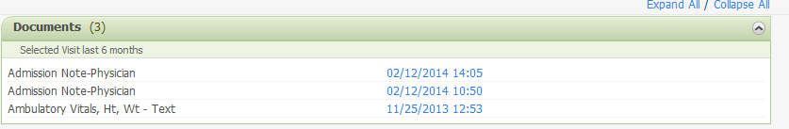
Exercise #4: Utilizing Component Options
Objective: Introduction to using component options to control a custom component in multiple ways.

In this exercise, custom component options will be used to create multiple ways to use a component without having to update the primary code.

- Look at the custom-components.js file that should already be open. Copy the lines below, and place after the definition of the document component as shown below. Make sure to replace the words “zzz” with your special mnemonic.
-----------------------------------------------------------------------------------------------------------
MPage.namespace("zzz.documents");
zzz.documents = function(){};

zzz.documents.twoYears = {
"lookback_ccl":"2 Y",
"lookback_desc":"2 years"
};

-----------------------------------------------------------------------------------------------------------
- The init function needs to be updated so that the ccl lookback prompt can be defined. These will be the options pulled from step 1 above. Note how the options are anonymously passed to the component as “component.options”. Copy/paste the code below and place it in the “init” function (changes from Exercise 3 are in yellow):
-----------------------------------------------------------------------------------------------------------
//code to perform before immediately rendering (usually updating params is needed)
var component = this;
//your options are attached to the options of the object behind the scenes
var comp_options = component.options;

//clear cclParams in case of refresh
component.cclParams = [];
component.cclParams.push("MINE");
//CAN USE ANY OR ALL OF THE FOLLOWING IN ORDER AS NEEDED:
component.cclParams.push(component.getProperty("personId"));
component.cclParams.push(component.getProperty("encounterId"));
component.cclParams.push(comp_options.lookback_ccl);
//this.cclParams.push(component.getProperty("userId"));
//this.cclParams.push(component.getProperty("PPRCode"));
//this.cclParams.push(component.getProperty("positionCd"));

-----------------------------------------------------------------------------------------------------------

- Next, we need rewrite the render function within the javascript to utilize these options in the subheader. Copy/paste the code below and place it into the documents render function. Note that the core architecture extends them to the component instance of “this.options” so that they can be accessed in the “init” or “render” functions (see below highlighted in yellow). Changes from Exercise 3 are highlighted in yellow.
-----------------------------------------------------------------------------------------------------------
var component = this;
var compId = component.getComponentUid();
var target = component.getTarget();
var record = component.data.DOCUMENTS;
var doc_length = record.DOCUMENT.length;
var comp_options = component.options;
var targetHTML = [];

//set and create subheader (uncomment and update if needed)
targetHTML.push(component.getSubHeader("Selected Visit last "+comp_options.lookback_desc));

//set the subtitle text next to header if needed (uncomment and update if needed)
component.setProperty("headerSubTitle","("+doc_length+")");

//do something here with the targetHTML (component.data will have data type defined by this.cclDataType)
targetHTML.push("<div class='zzz-documents'><table>");
for (var i=0;i<doc_length;i++) {
var docObj = record.DOCUMENT[i];
var paramStr = component.getProperty("personId")+"|"+component.getProperty("encntrId")+"|" + docObj.EVENT_ID + "|Documents|31|CLINNOTES|341|CLINNOTES|1";

targetHTML.push(
"<tr>",
"<td title='Event Id: ", docObj.EVENT_ID,"'>", docObj.TITLE,"</td>",
"<td class='doc-detail'><a href=\"javascript:MPAGES_EVENT('CLINICALNOTE', '",paramStr,"')\">", docObj.DATE,"</a></td>",
"</tr>"
);
} // end for

// Close the table
targetHTML.push("</table></div>");

target.innerHTML = targetHTML.join("");

//this may or may not be needed
//component.addEventHandlers();

-----------------------------------------------------------------------------------------------------------
- The last step is let the javascript core architecture know which “option” to use. Update the section div in the html file as shown below in yellow.
-----------------------------------------------------------------------------------------------------------
<div class="section with-header" namespace="zzz.documents" options="zzz.documents.twoYears">
-----------------------------------------------------------------------------------------------------------

- Refresh your MPage, and you should now see 2 years of documents.

Bonus Exercise
- Create a new set of options different than “twoYears” which have your own personal lookback range, and utilize them in the component.
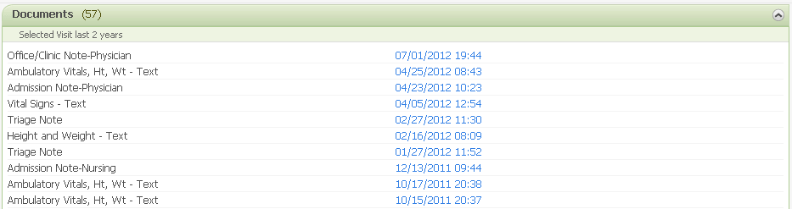

Exercise #5: Adding Tooltips Using jQuery
Objective: Show how to add utilize jQuery plugins and other utility javascript in a custom component.

- In the zzz_custom_mpage folder, navigate to the js folder and open jquery.tooltip.js. Copy/paste this code to the TOP of the custom-components.js file. This code is a plugin to easily customize tooltips, and it assumes that the jQuery library (jquery-1.9.1.min.js) already exists. We have to copy the contents of this file to the top of the custom-components.js file so that it can be pulled in without having to update the HTML file (instructor will explain).
- Copy/paste the following CSS to your custom-components.css file, and save the file. This code is used to style the tooltips.

-----------------------------------------------------------------------------------------------------------

/* JQuery Tooltip Plugin Styles */
.ttip {position: absolute;zoom:normal;z-index: 3000;border: 1px solid #000;color:#000;background-color: #ffc;padding: 5px;opacity: 1;}
.ttip h3, .ttip .body, .ttip .url { position:relative; zoom:normal; margin: 0; }
.ttip h3 { font-weight: normal; font-size: 13px; }

-----------------------------------------------------------------------------------------------------------

- We next need to update our documents javascript (in custom-components.js file) to have an event handler function that can be called after our render function is complete. In the template, there is already a function ready to be manipulated to handle this called “addEventHandlers”. The instructor will explain how this plugin works, but note that it turns the title attribute into an html tooltip.
-----------------------------------------------------------------------------------------------------------

zzz.documents.prototype.addEventHandlers = function() {
var component = this;
var compId = component.getComponentUid();
var target = component.getTarget();

$("#"+compId+" .hvrData").tooltip({"track":true,"delay":150});
};

-----------------------------------------------------------------------------------------------------------

- Uncomment the last line in the render function to execute the “addEventHandlers” function after the component is loaded. This is in the custom-components.js file.
-----------------------------------------------------------------------------------------------------------

//this may or may not be needed
component.addEventHandlers();

-----------------------------------------------------------------------------------------------------------

- The last step is to add the “hvrData” class as shown below in yellow to the first td element with the title attribute. This is in the custom-components.js file.
-----------------------------------------------------------------------------------------------------------

"<td class='hvrData' title='Event Id: ",docObj.EVENT_ID,"'>", docObj.TITLE,"</td>",

-----------------------------------------------------------------------------------------------------------

- Refresh your MPage, and the title originally put on each row showing the event id should now appear in a tooltip.

Bonus Exercise
- Update the tooltip to have a 1000ms fade. This may require looking at the options in the tooltip.js file.

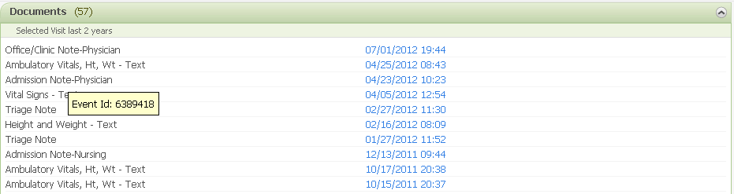

NOTE: This class will be completing one of the next 3 exercises, depending upon which verions of Mpages is currently installed (Most will be doing Exercise #6).

Exercise #6: Utilizing Components into a Standard V6 MPage
Objective: Implement a previously created custom component into a standard V6 MPage

In this exercise, we will take the previously created documents component and implement it into a standard MPage which for this exercises purpose will be a new MPage view. To prevent confusion, the instructor may or may not walk through these steps with the class.

- Open up Bedrock, and click on “Quality Reporting and MPage Setup”. If this options does not exist, the instructor will have to grant you privileges.


- Under “Solutions” click on MPage, and then click “View Builder” under Wizards.
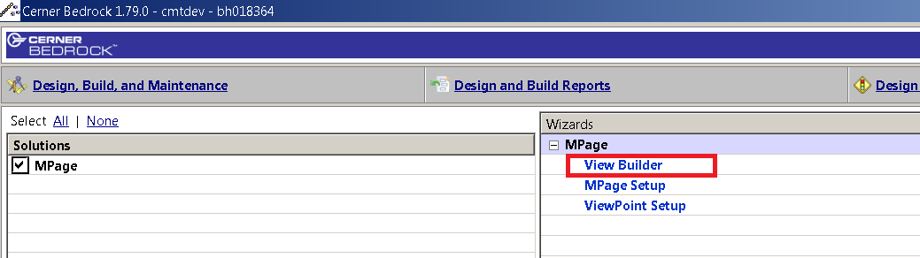

- Click the “Add” button, and then update the Display to “Training MPage”
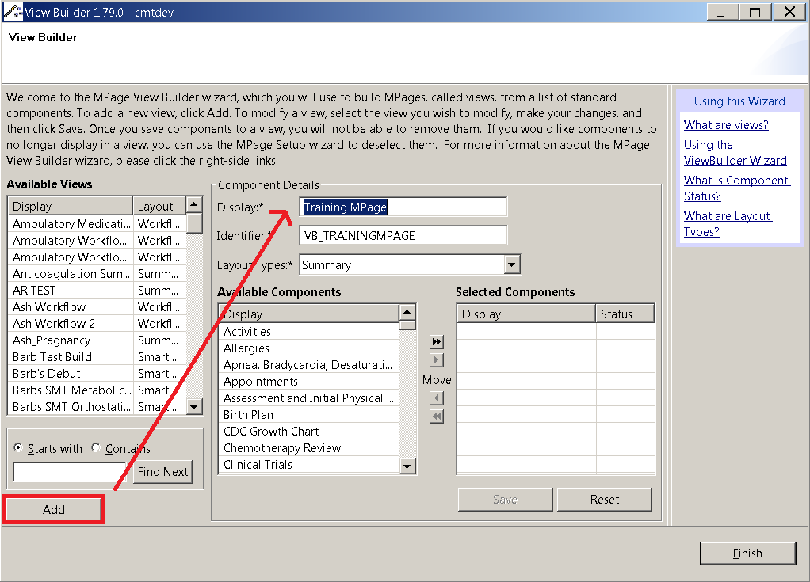

- Next, add the “MPage-level Settings”, “Custom Component 1”, and “Custom Component 2” sections setting the “MPage-level Settings” to required, and the other two to whatever you want. The MPage-level Settings is not an actual component, but is required if you want to turn on/off the demographic banner and name your MPage. After done, click the “Save” button, and then the “Finish” button.
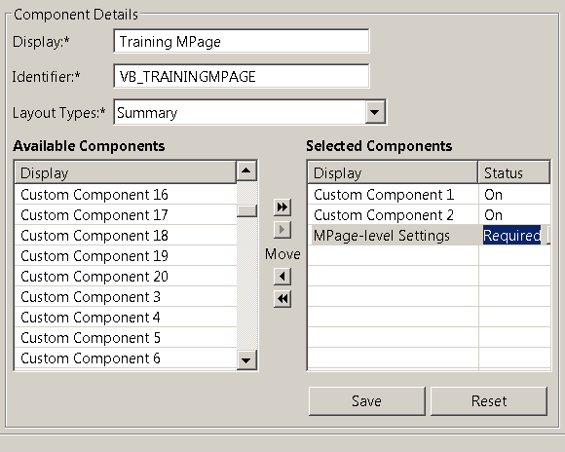

- Click on the MPage Setup link.
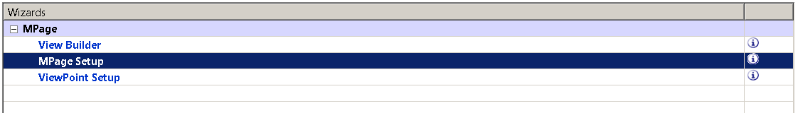

- Select your newly created MPage view from the drop-down list provided.
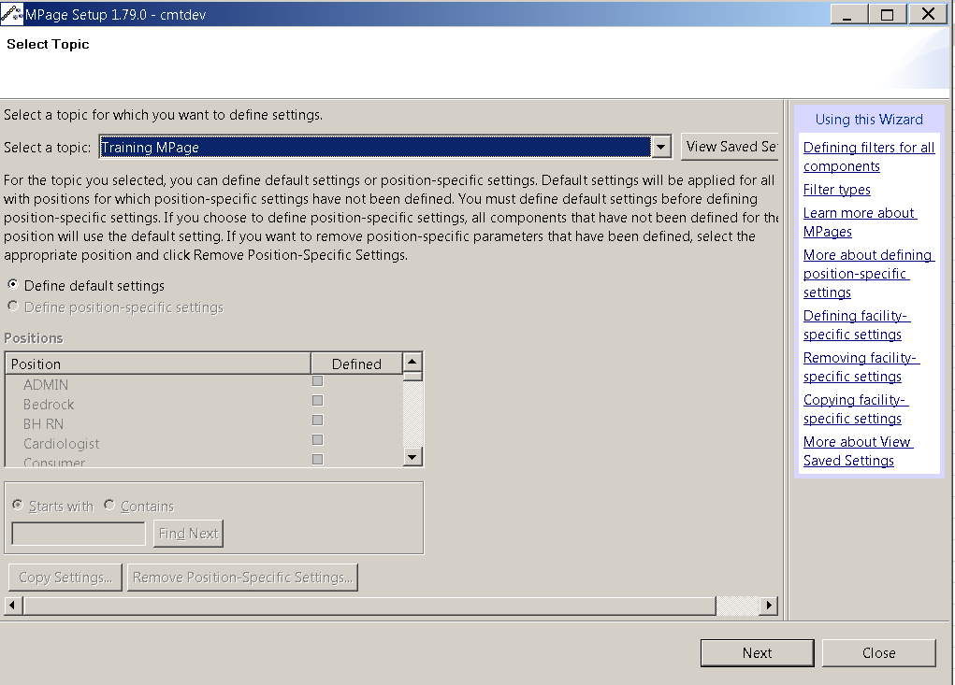

- For now, we are going to work under “default” for positions which will put this component under all positions. Note that this component can always be turned on and off for “default,” and if it later needs to be added to a specific position (ie. DBA), that can be done as well. Click “Next”.

- As soon as the Components appear, click on “Define MPage Layout” shown below circled in red:
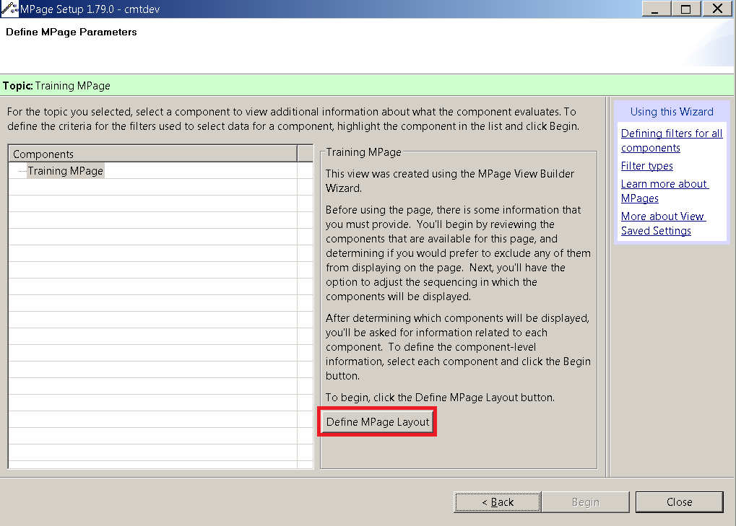

- Click on one of the custom components, in this case “Custom Component 1,” and then click “Ok”.
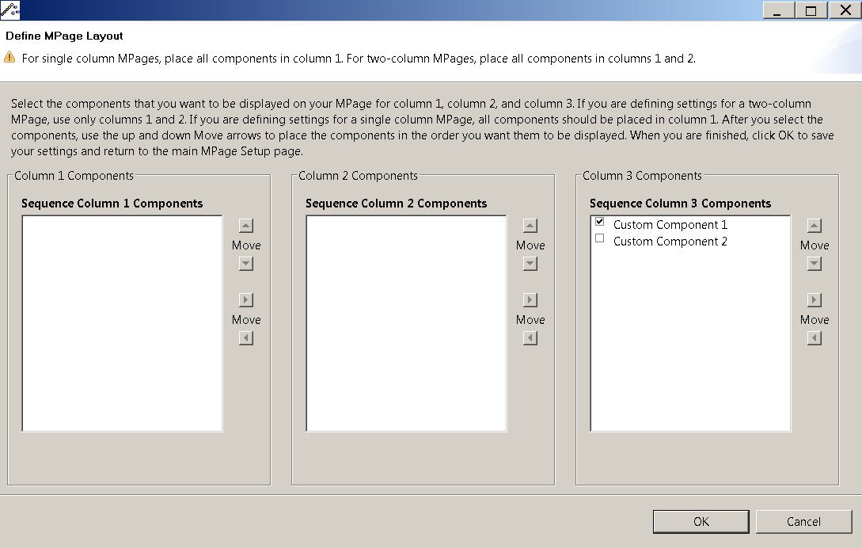

- This new component should now appear in the list of components, and also the Mpage-level Settings should now appear. Double-click on “Custom Component 1” in the new component list
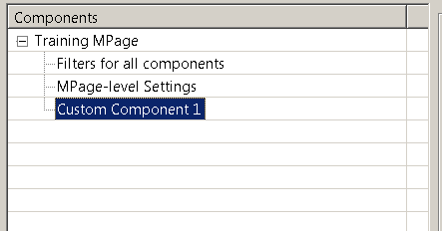

- For the first filter, put the label or title as whatever you want to call it which in this case is “Custom Documents”. Other settings can be changed as needed. Finally, click save, and then proceed by clicking on the “Custom Component 1 Namespace” filter.
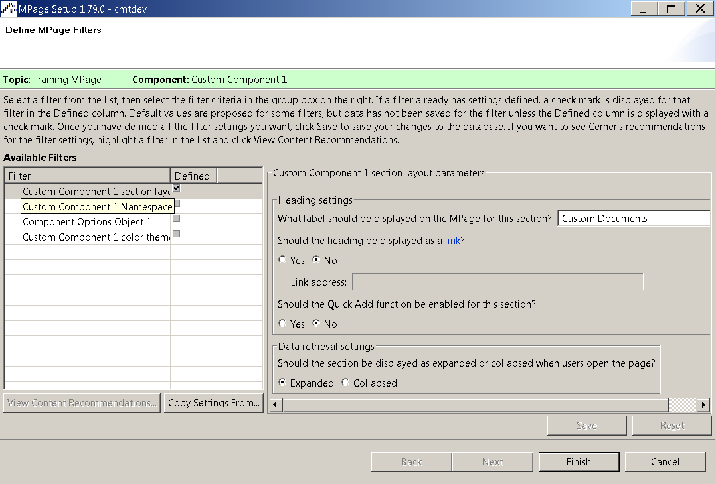

- For the namespace filter, this is where you put the “zzz.documents” namespace (replacing “zzz” with your special mnemonic) created in your javascript. Note that for the stand-alone MPage, we put it as an attribute on the component section. After complete, click save and proceed by clicking on the “Component Options Object 1” filter.
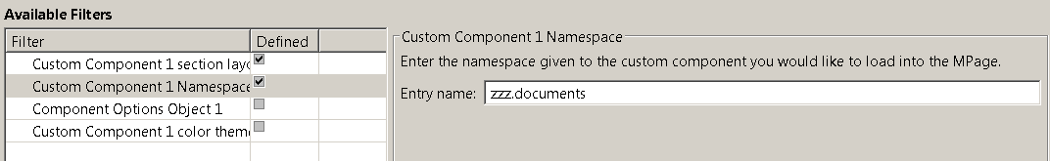

- The last step in Bedrock is update the options to the name of your value for the documents options shown below. Click save after done.
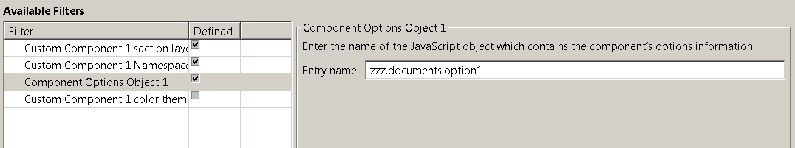

- Next cycle server 535 to allow for the MPage to pick-up the new settings. Note that this step can be skipped if you add a prompt value of 8 at the end of the report parameters below. This will allow the MPage to ignore cached settings at the cost of decreased performance.
- Next we are going to test our code in the code warehouse to verify it works before moving to the WAS where web server and IE caching become prevalent. Create a copy of an MPAGES_6_x folder and rename it to MPAGES_6_x_SANDBOX.
- Create a folder called CUSTOM_MPAGE_CONTENT within the newly created folder from step 15.
- Copy and paste your custom-components folder which contains the javascript and css to the newly created CUSTOM_MPAGE_CONTENT folder created in step 16. If a folder already exists, feel free to copy over it as this new folder is your own personal “sandbox.”

- Set-up prefmaint so that it matches the following for the tab. Make sure to replace <static content path>\MPAGES_6_x_SANDBOX with the path to your static_content folder (note that the pipe “|” character is required):
  - Report Name: mp_unified_driver
  - Report Params: "MINE", $PAT_PERSONID$, $VIS_ENCNTRID$, $USR_PERSONID$, $USR_PositionCd$, $PAT_PPRCode$, "$APP_AppName$", "<static content path>\MPAGES_6_x_SANDBOX|", "<View or ViewPoint Identifier from step 4>"

- Next we will want to run the code from the WAS to demonstrate how much faster it runs. Merge your code within your “<static content path>\MPAGES_6_x_SANDBOX\CUSTOM_MPAGE_CONTENT” folder into the “<static_content path>\CUSTOM_MPAGE_CONTENT” folder.

- Run mp_refresh_static_content "MINE","custom_mpage_content" go from the backend.

- Close Powerchart completely, and set-up your existing tab in prefmaint so that it matches the following:
  - Report Name: mp_unified_driver
  - Report Params: "MINE", $PAT_PERSONID$, $VIS_ENCNTRID$, $USR_PERSONID$, $USR_PositionCd$, $PAT_PPRCode$, "$APP_AppName$", "", "<View or ViewPoint Identifier from step 4>"

- Open up Powerchart and navigate to the Training MPage tab. Observe this newly created component. Congratulations! You have successfully created, tested, and implemented a custom component into a standard MPage.

- If you don’t see the changes after 5-6 minutes, then you will need to manually cycle the webservers and/or possibly restart your Citrix session in the case of IE caching.

Bonus Exercise
- Proceed to add your hyperlinks component to the MPage.

Exercise #7: Utilizing Components into a Standard V5 MPage
Objective: Implement a previously created custom component into a standard V5 MPage

In this exercise, we will take the previously created documents component and implement it into a standard MPage which for this exercises purpose will be a new MPage view. To prevent confusion, the instructor may or may not walk through these steps with the class.

- Open up Bedrock, and click on “Quality Reporting and MPage Setup”. If this options does not exist, the instructor will have to grant you privileges.

- Under “Solutions” click on MPage, and then click “View Builder” under Wizards.

- Click the “Add” button, and then update the Display to “Training MPage”

- Next, add the “MPage-level Settings”, “Custom Component 1”, and “Custom Component 2” sections setting the “MPage-level Settings” to required, and the other two to whatever you want. The MPage-level Settings is not an actual component, but is required if you want to turn on/off the demographic banner and name your MPage. After done, click the “Save” button, and then the “Finish” button.

- Click on the MPage Setup link.

- Select your newly created MPage view from the drop-down list provided.

- For now, we are going to work under “default” for positions which will put this component under all positions. Note that this component can always be turned on and off for “default,” and if it later needs to be added to a specific position (ie. DBA), that can be done as well. Click “Next”.

- As soon as the Components appear, click on “Define MPage Layout” shown below circled in red:

- Click on one of the custom components, in this case “Custom Component 1,” and then click “Ok”.

- This new component should now appear in the list of components, and also the Mpage-level Settings should now appear. Double-click on “Custom Component 1” in the new component list

- For the first filter, put the label or title as whatever you want to call it which in this case is “Custom Documents”. Other settings can be changed as needed. Finally, click save, and then proceed by clicking on the “Custom Component 1 Namespace” filter.

- For the namespace filter, this is where you put the “zzz.documents” namespace (replacing “zzz” with your special mnemonic) created in your javascript. Note that for the stand-alone MPage, we put it as an attribute on the component section. After complete, click save and proceed by clicking on the “Component Options Object 1” filter.

- The last step in Bedrock is update the options to the name of your value for the documents options shown below. Click save after done.

- Next cycle server 535 to allow for the MPage to pick-up the new settings.
- Copy and paste your custom-components folder which contains the javascript and css to the custom_mpage_content folder. Note that this may require saving over what already exists. This is fine since it only contains examples. If you don’t want to do this, manually copy the javascript and css to their respective js and css folders within the custom-components folder that should already exist.

- If you want to run this MPage without having to load the static content to the webservice, set-up prefmaint so that it matches the following for the tab. Make sure to replace <static content path> with the path to your static_content folder:
  - Report Name: mp_unified_driver
  - Report Params: "MINE", $PAT_PERSONID$, $VIS_ENCNTRID$, $USR_PERSONID$, $USR_PositionCd$, $PAT_PPRCode$, "$APP_AppName$", "<static content path>\UnifiedContent", "<View or ViewPoint Identifier from step 4>"

- If you want to run this MPage using the static content loaded to the webservice, you will need to:
  - Run mp_refresh_static_content "MINE","custom_mpage_content" go from the backend
  - If you don’t see the changes after 5-6 minutes, then you will need to manually cycle the webservers

- Open up the Training MPage tab, and observe this newly created component. Congratulations! You have successfully created, tested, and implemented a custom component into a standard MPage.

Bonus Exercise
- Proceed to add your hyperlinks component to the MPage.

Exercise #8: Utilizing Components into a Standard V4 MPage
Objective: Implement a previously created custom component into a standard V4 MPage

In this exercise, we will take the previously created documents component and implement it into a standard MPage which for this exercises purpose will be Inpatient Summary V4. To prevent confusion, the instructor may or may not walk through these steps with the class.

- Open up Bedrock, and click on “Quality Reporting and MPage Setup”. If this options does not exist, the instructor will have to grant you privileges.

- Under “Solutions” click on MPage, and then click “MPage Setup” under Wizards.
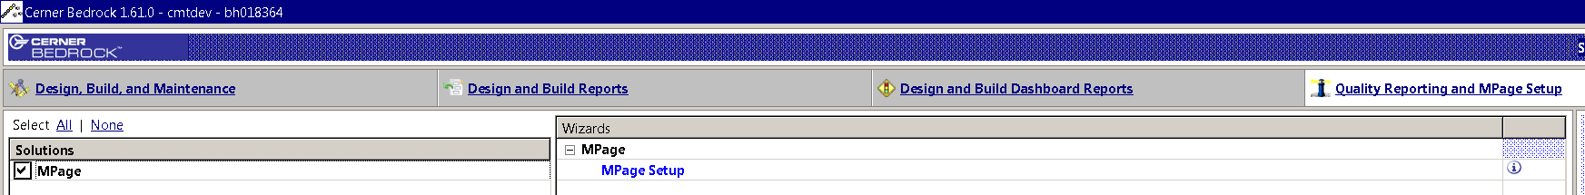

- For the topic, select your V4 MPage which in this case is Inpatient Summary V4.
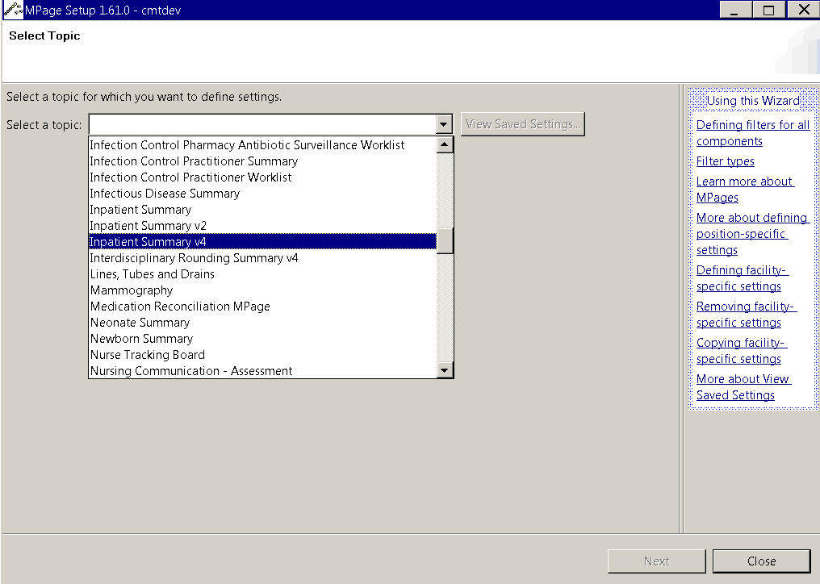

- For now, we are going to work under “default” for positions which will put this component under all positions. Note that this component can always be turned on and off for “default,” and if it later needs to be added to a specific position (ie. DBA), that can be done as well. Click “Next”.
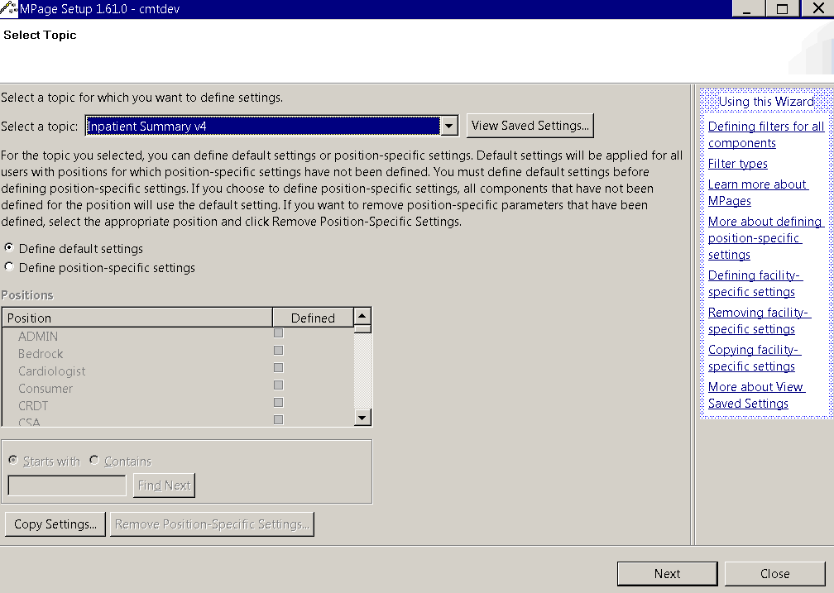

- As soon as the Components appear, click on “Define MPage Layout” shown below circled in red:
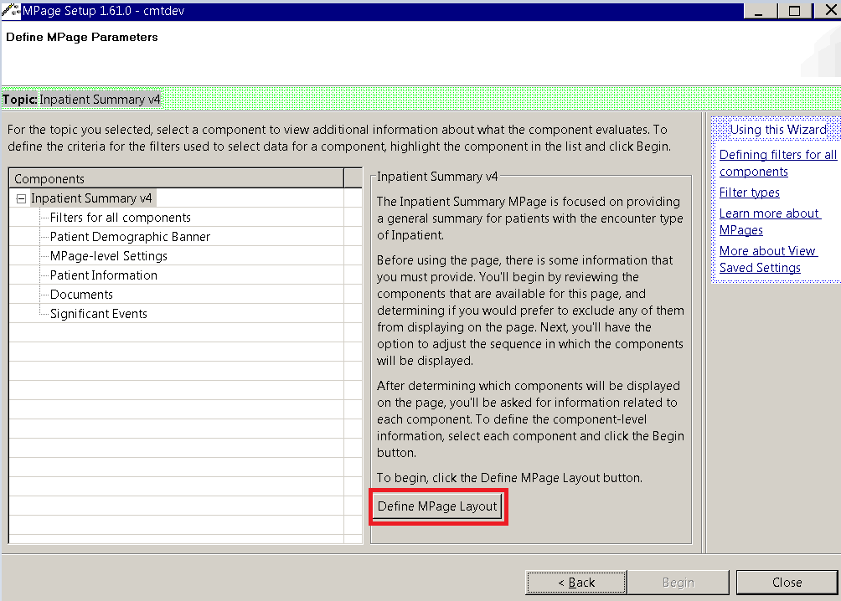

- Click on one of the custom components, in this case “Custom Component 1,” and then click “Ok”.
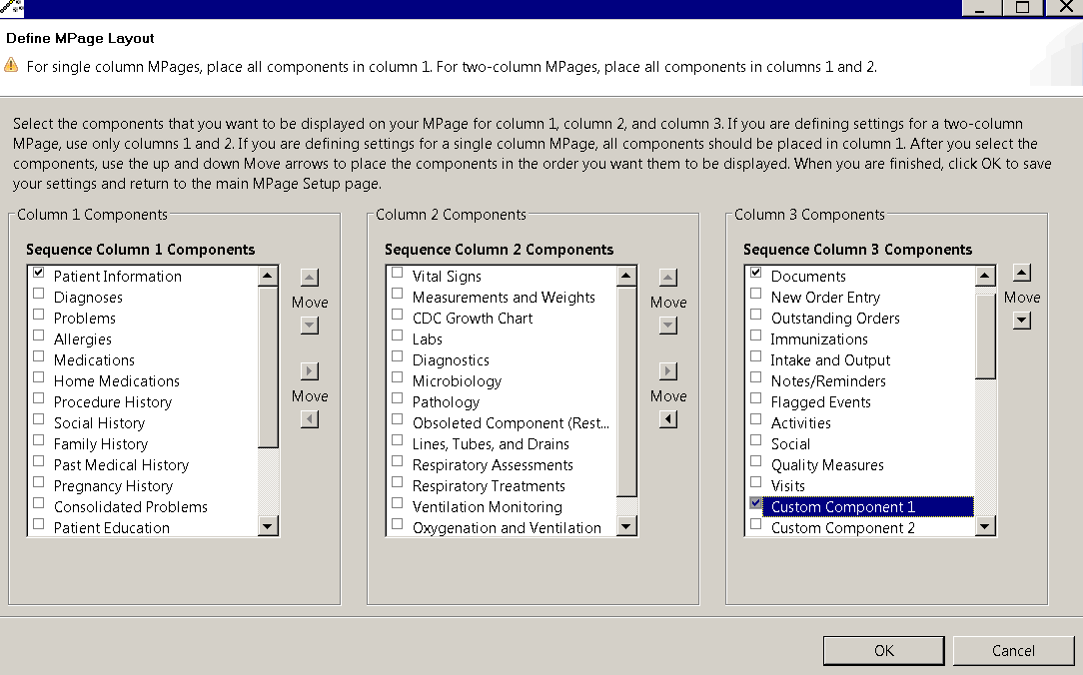

- This new component should now appear in the list of components. Double-click on “Custom Component 1” in the new component list
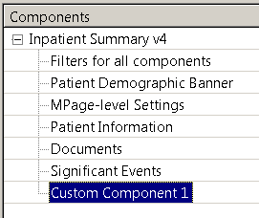

- For the first filter, put the label or title as whatever you want to call it which in this case is “Custom Documents”. Other settings can be changed as needed. Finally, click save, and then proceed by clicking on the “Custom Component 1 Namespace” filter.
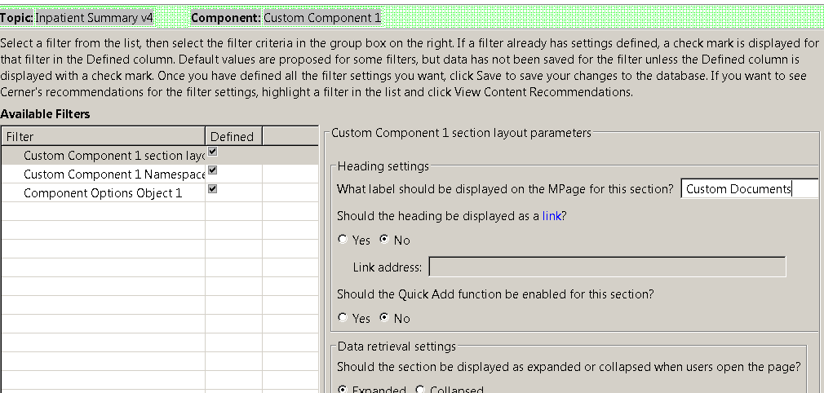

- For the namespace filter, this is where you put the “zzz.documents” namespace (replacing “zzz” with your special mnemonic) created in your javascript. Note that for the stand-alone MPage, we put it as an attribute on the component section. After complete, click save and proceed by clicking on the “Component Options Object 1” filter.
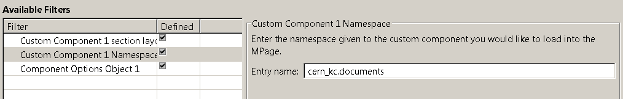

- The last step in Bedrock is update the options to the name of your value for the documents options shown below. Click save after done.
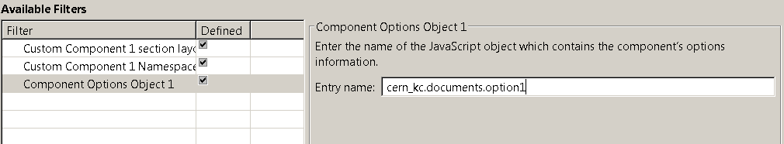

- The final step is to copy paste your custom-components folder which contains the javascript and css to the MasterSummary_V4 folder. Note that this may require saving over what already exists. This is fine since it only contains examples. If you don’t want to do this, manually copy the javascript and css to their respective js and css folders within the custom-components folder.

- Open up the Inpatient Summary V4 MPage tab, and observe this newly created component. Congratulations! You have successfully created, tested, and implemented a custom component into a standard MPage.

Bonus Exercise
- Proceed to add your hyperlinks component to the standard MPage.

